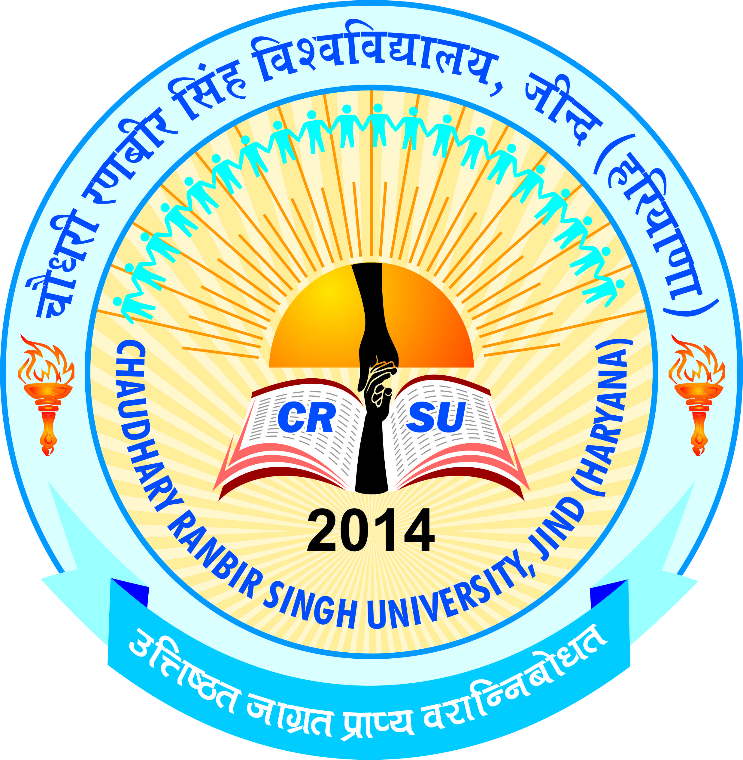 | pkS/kjh j.kchj flag fo'ofo|ky;]thUn  Chaudhary Ranbir Singh University, Jind  (Established by the State Legislature Act 28 of 2014 and recognized U/S 2(f) & 12-B by UGC Act 1956) | 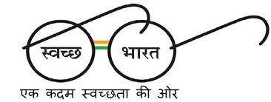
ADMISSION NOTICE-3/2019
Admission for B.A-B.Ed/B.Sc-B.Ed four year integrated course and B.El.Ed Four Year Professional Degree Programme
Online applications are invited from candidates for admission in B.A-B.Ed/B.Sc-B.Ed four year integrated course and B.El.Ed Four Year Professional Degree Programme being run in affiliated Colleges of this University for the Academic Session 2019-20. The Prospectus containing all the details (List of Colleges, Intake, Eligibility, Fee etc.) will be available on University website. i.e. www.crsu.ac.in. The Opening Date of Online Registration is 18.06.2019 and Closing Date is 06.07.2019.
Sd/-
REGISTRAR

